1. **Data Driven Predictive Maintenance of Discrete Manufacturing System Components**
2. **Prognostics for gradual loss of conveyor belt tension in Discrete Manufacturing Settings**
3. **Power Consumption patterns for detecting gradual equipment wear and predictive maintenance in a factory automation system**

**Abstract: This paper presents the use of data-driven prognosis of an incipient gradual behavioral deterioration of conveyor belts (gradual loss of belt tension). Conveyor belts used for transportation of material, pallets, or equipment between processing workstations of discrete manufacturing systems. The developed prognostic model which is an artificial neural network (ANN) which learns conveyor belt driver engine’s power consumption pattern ~~by utilizing.~~ Conveyor belt driver’s power consumption data is collected under different belt tensions and workload (number of pallets residing on conveyor zones at a time) of described device. During run time, trained artificial neural network (ANN) take real time power consumption of conveyor belt driver engine and load data from testbench and predict a belt tension class. If Consecutive predicted belt tension class belongs to not useful belt tension classes, then it is an indication of gradual loss of belt tension and maintenance steps must be taken to avoid catastrophic situation.**

# 1. Introduction

Modern discrete manufacturing systems composed of a lot industrial machines and equipment which are vulnerable to different faults. The consequences of these faults ranging from soft inconvenience to life-threating situations. Furthermore, for production system there is a certain cost associated with every occurrence of fault which includes production line shutdown, possible repair of collateral damage and parts, and labor for replacing the failed component or machinery. In addition to this, gradual deterioration of devices or equipment of a production system significantly affects the downtime of production machines or other heavy-duty equipment. Gradual equipment failures remain un-noticed until the effects are enough and may causes on site jeopardizing situations. The maintenance cost associated with the above-mentioned faults has significant impact on loss revenue. According to a study[1], the gradual wear of equipment is responsible for 3% to 8% decrease in oil production, causing up to $20 billion losses in the US economy.

Due of the associated risks and costs of failures, an early stage equipment failure detection and prediction for prognosis maintenance is crucial to avert serious disruptions to production systems. To detect an incipient equipment wear, the data from plant sensors is utilized, for example data from vibration, temperature, pressure, and humidity sensors used in online maintenance[2]. In addition to the above-mentioned sensor data, energy consumption patterns associated with equipment or pieces of equipment is also promising to incipient a gradual equipment failure [3,4], an example of such fault is gradual loss in belt tension of a belt conveyor transportation system in discrete manufacturing systems.

The aim of this work is to categorize the testbed equipment’s behavior based on power consumed by equipment, in this case the equipment is the driver motor of conveyor belt. The patterns will be utilized to compare expectations with the real-time data coming from the testbench. This paper is organized as follows: Section 2 briefly presents the theoretical background of this work and related research. Section 3 describes the testbed used. Section 4 gives details on the method used for detecting gradual loss of belt tension in conveyor belt in the discussed factory automation setting. Section 5 describes the results obtained. Section 6 concludes and outlines future work.

# 2. Background

## Maintenance Strategies

The performance of a production system is significantly influenced by maintenance strategies adopted by site managers. A good and effective maintenance policy increases the equipment/machine life and extends its availability time, on the other hand an ineffective or poor maintenance strategy decreases the equipment life as well as available time which leads to unexpected frequent sudden breakdowns. Two types of maintenance policies are being used in industry and known as reactive and proactive maintenance. Reactive maintenance policy includes Run-2-Failure strategy and proactive maintenance includes both preventive and predictive maintenances strategies [5].

Run-2-Failure (R2F) and preventive maintenance (PvM) are the two major maintenance strategies, used for production system. Fire-fighting maintenance, in literature also known as reactive, fault driven or Run-2-Failure maintenance strategy, is a maintenance strategy where maintenance activity starts when either equipment’s obivious functional failure, malfunction or equipment breakdown occurs. As it is a reactive maintenance strategy so corrective measurements are governed by random failure events and some time these failures leads to very large equipment or machine downtime, an extensive equipment repairing time as well as high repairing cost which decreases the production of a manufacturing system [5,6,7,8].

Preventive maintenance also, known as Time base maintenance which helps to slow down the equipment, component or machine deterioration by doing planned periodic plant inspection and repairs for example periodic lubrication and calibration etc. [6]. In preventive maintenance strategy, the part for maintenance is replaced on a specific date. This act makes sure a low possibility of sudden failure for the part involved. Compared to R2F, PvM provides more safety since a part failure is not mandatory prior to maintenance. But this is not cost-efficient enough, because some parts will be functional after the removal, so the replacement wasn’t necessary [7,8].

Predicted maintenance which is a type of condition-based maintenance, uses prognostic models to foretell the equipment, component, or machine condition. These prognostic models continuously monitor parameters of the under-test equipment or component. These parameters come from sensors such as energy analyzer modules, temperature, vibration, corrosion, and humidity etc. These parameters used for training prognostic model which can foretell/predict the failure in test equipment before it occurs [6,7,8,9]. These models may be data driven, knowledge driven, or model driven, Figure1 shows taxonomy of predictive maintenance.

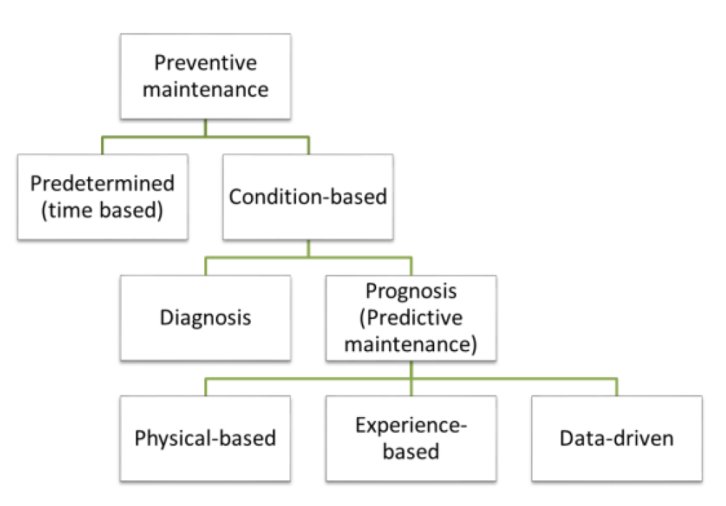

Figure : Taxonomy for Predictive maintenance [10]

State of the art prognostic models used for detecting and predicting faults are either data-driven or model driven. Model-driven fault prognosis model uses a mathematical model for system for analyzing the new incoming data from equipment. However, these models do not need any historical data for learning systems parameters. The disadvantage of this approach is to ensure accuracy of developed model as system complexity increases.

Data driven fault detection use the historical observations of equipment data. For data driven fault prognosis system a mathematical model is not required [11,12].Data driven model learns the abnormal system behavior through machine learning techniques (ML) and statistical algorithms for example artificial neural network (ANN) or support vector machine (SVM) etc. Data driven models are applied for foretelling faults when the basic operating principle of a system is hard to model, or system is very complex. Data driven models are data hungry which is the biggest challenge associated with them as they require huge amount of good quality data for training as mentioned in [15], data-driven models require a good quality data up to two years. Due to limitations of model driven prognostic models, predictive maintenance uses data driven model.

State of the art Predictive maintenance techniques are either passive or active [14]. Passive maintenance techniques either use output signals from already existing on site sensors and verify performance themselves or uses the installed on-site test sensors to monitor the desire parameter (pressure, power consumption, vibration etc.) and use the installed sensor’s output signals to judge the performance by comparing the results with the expected results [2]. On the other hand, active maintenance techniques allow user to inject test signals to the equipment in real-time to observe the equipment’s response to the injected input as well as its modifications.

Mostly, for predictive maintenance data driven prognostic models are being used to predict equipment anomaly or gradual deterioration of a component so for good quantification of machine/equipment faults we need to provide a huge amount of good quality data for the training of the prognostic model which may be a ML or DL regression or classifier model. It is necessary to collect good quality data of interested parameters for all working conditions of the equipment. The collected data is used for investigating thresholds for healthy and unhealthy equipment’s operating regions as well as for training the model, for example in [15] real time vibration information is collected until failure to create a vibration based database of suitable amplitudes associated with the bearing defective frequency and its first 5 harmonics.

## Artificial Neural Network

State of the art machine learning (ML) and deep learning (DL) algorithms can be used for predicting anomalies in industrial equipment or a machinery part. Algorithms offered by ML, learn system behavior and patterns from training data. Trained model is then used to make prediction on new incoming sample data while deep learning (DL) which is a sub-set of ML algorithms that uses one or more hidden layers with several processing neurons known as nodes, see Figure 2 [16].

Figure 2 show a simple ANN with one input layer having 3 nodes representing the data coming from sensors or desire equipment parameters, 2 hidden layers with 4 processing nodes and one output layer with one node. ANN are good at function approximation and system parameter learning with the feed forward and backward propagation respectively. The ANN learning process is extensively discussed in [17,18,19].

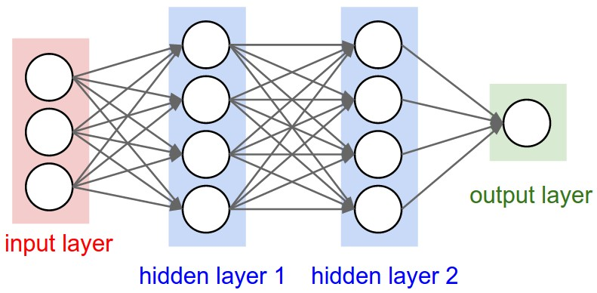

Figure : A simple ANN with 2 hidden layers

Different deep learning flavors like artificial neural network (ANN), Convolutional Neural Networks (CNN) Long-short term memory (LSTM) and Recurrent neural networks (RNN), are widely used in predictive maintenance due to their inherit ability to capture, learn and retain nonlinear failure patterns [21]. In [17,20], authors extensively review the DL algorithms, architectures, and methodologies (supervised, unsupervised or hybrid) which are being used for predictive maintenance and presents a case study of engine failure prediction. According to [22] ANNs differ from traditional statistical techniques in their ability to successfully learn nonlinear features of a time series, and ANNs have been widely used in forecasting equipment health and failure.

In addition to other fields DL is also making its way in predictive maintenance day by day. Beside their positive aspects, deep learning models has a serious negative aspect which is related to data computational parameters as DL models need tons of data for training to produce quality results ~~as well as for based on the application DL models require hundreds or thousands of parameter.~~

# 3. Testbench

FASTory line, see Figure 3, is used as a testbench in this research work. In past FASTory line was used in factory to assemble cell phone parts like frames, keypads, and screens. After retro fitting, FASTory line simulates its original cell phone assembling operations by drawing the main parts (frame, keypad, screen) of cell phone on a pallet in different shapes and colors. Figure 4 shows the layout of FASTory line.

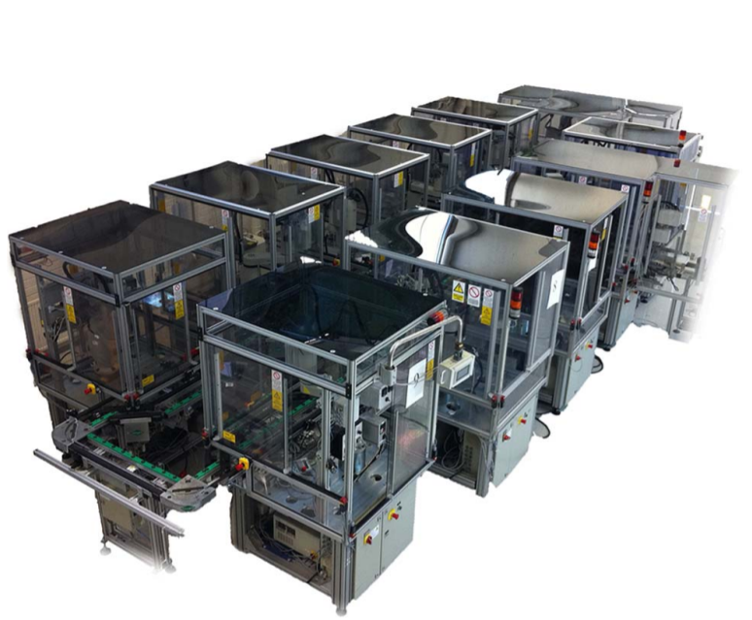

Figure : FASTory Line

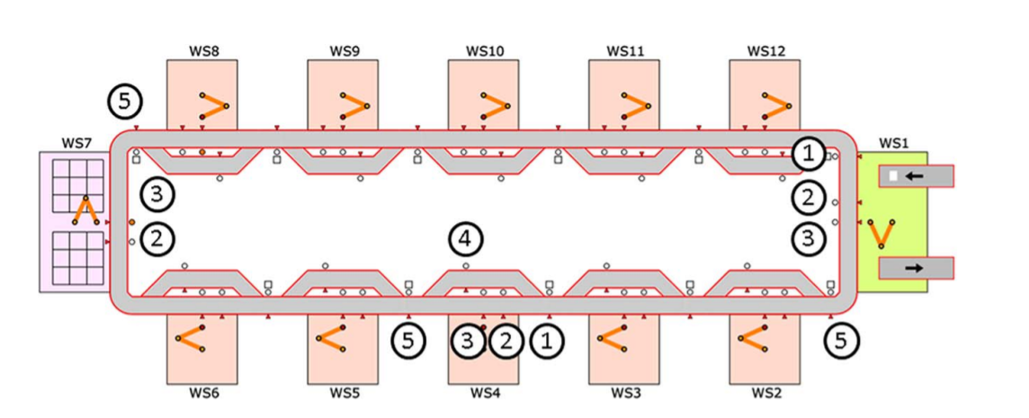

Figure : Testbench layout

The testbed comprises ten identical workstations, one buffer station and one paper loading and unloading station. W7 is the pallet buffer station, which is used for loading and unloading empty pallets, W1 loads a paper onto pallet for drawing and unloads the paper which contains the complete drawing of selected cell phone model. The remaining ten processing workstations are labeled W2–W6 and W8–W12. Each of this production workstation consists of one main conveyor, one bypass conveyor and one SONY SCARA robot, for workstations 2,6 and 9-12. Other cells have robots from OMRON, ABB and YASKAWA.

Each production workstation contains two conveyors: a main conveyor which transfers a pallet to the robot and a bypass conveyor moves the pallet to the next station once the workstation is busy. The FASTory line follows the closed loop topology which provides an uninterrupted path for pallets, thereby increasing the productivity/space ratio. Both conveyors split into different zones which are marked in Figure 4 and referred as Z# in this paper. The ins and outs of the workstations are located at Z1 and Z5 respectively. Main conveyor has four zones (Z1, Z2, Z3, Z5), for each zone there is a stopper and presence sensor for stopping and checking the presence of a pallet, Z3 is the production zone of each workstation. The Z1 of each workstation has a RFID tag reader at zone one which is used to read pallet ID also Z1 of next workstation and Z5 of current workstation are same. The bypass conveyor has one zone and one stopper and can process only one pallet.

The FASTory line is equipped with S1000 as well as an E10 energy analyzer module. S1000 is a smart, web service enabled controller which is being used for invoking operations and managing the shop floor equipment and devices. Besides providing the functionalities like a genetic controller, S1000 is capable to expose equipment data and methods from line as RESTful services [23]. Among such service the event subscription mechanism is developed. Such mechanism enables event-driven behavior in the system. Exposed event notifications (Table 1) include information about energy consumption (via S1000 energy meters), CAMX state events (e.g. pallet input to a conveyor piece etc.).

Table : Received Event Notification from Testbench

|  |  |  |
| --- | --- | --- |
| Sr# | Event Notification | Description |
| 1 | EnergyMeter | Robot/conveyor/controller energy consumption, of each working cell published at a time interval of one second. |
| 2 | DrawStart/DrawEnd | cell ID, recipe number, pen color  time stamp |
| 3 | EquipmentState | Cell ID, State of conveyor zones, pallet ID, time stamp |

# 4. Prognosis of gradual loss of belt tension in Conveyor belt operated transportation system

Conveyor belts are used to transport sand, coal, and minerals etc. as either powder or blocks over long distances in mining, metallurgy and transportation industries, on the other hand in discrete production system conveyor belts are used to transport equipment, pallets and other tools between workstations. Belt conveyor is the perfect conveying equipment to transfer material or goods over long distances, efficiently. For proper and efficient material transportation, conveyor belts need certain traction force and belt tension to overcome the path friction. The traction force is provided by conveyor motor driver engine. The belt motor driver power and belt tension are calculated by following the procedures defined in DIN and CEMA standards [24,25]. Once parameters are calculated the belt conveyor system is installed as well as nominal belt tension is adjusted for an efficient material transportation.

After installation and setup, belt conveyor system works efficiently until it has proper belt tension but with passage of time nominal belt tension of belt conveyor system starts losing. The losing of belt tension is a gradual process and remains un-noticeable until some serious faults occurs in the transportation system or significant belt wear observed. Both too high and too low belt tension are harmful for conveyor belts. Too low belt tension leads to belt slippage at head pully, excessive heat generation, belt wear and tear (damage rubber belts), unexpectable delays in material transportation. On contrast too high belt tension leads to an excessive stress on motor shaft, bearings and belts which can damage driver motor also It leads to belt mistracing issues and uneven belt wears.

Traditionally, operators do weekly, bi-weekly, or monthly inspections of conveyor belts to keep everything health and working, i.e. follow scheduled preventive maintenance strategy, but to do so, they need to stop whole production plant or a sector of production plant which decreases plant production efficiency. This preventive maintenance strategy can be replaced with predictive maintenance strategy by carefully monitoring the parameters which are associated with belt tension and able to show parameter variation as soon as belt tension starts deviating from nominal value. These parameters could be data coming from vibration sensors, driver motor temperature, power consumed by driver motor etc. For this research work power consumed by motor driver and load on conveyor belt are the interested parameters which are used for investigating the relationship between driver motor power consumption, belt tension and load as well as for predicting the belt tension.

## Monitoring relevant test bed generated data

For this research work, relevant data generated from testbench is related to power consumed by the conveyor belt motor driver. As mentioned in section 3, all workstations of FASTory line are equipped with E10 energy analyzer modules which is an expansion module to S1000 controllers and provides 3-phase electrical power consumption monitoring, see Figure 5. The connections to E10 energy analyzer module are as follow, Phase A is assigned to the robot, phase B is allocated to the cabinet, I/Os and the controller, while phase C is assigned to the conveyor system (including main and bypass). Power is measured by sampling current and voltage, the current sampled by a current transformer (CT) connected to +Ia-, +Ib- and +Ic- terminals and the voltage is measured by direct connection of the 3 phases and neutral to the Vn, Va, Vb and Vc terminals of the E10 expansion module. For this research work the phase C energy values are of interest for us.

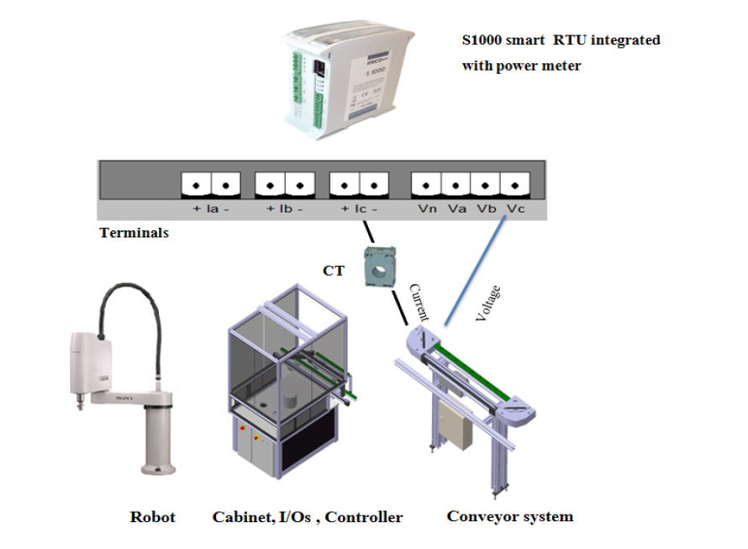

Figure : Monitoring Power Consumption in Testbench

## Data collection, preparation, and feature extraction

During this work data is collected for two separate cases “static case and dynamic case”. The data collected in static case used for investigation of belt tension thresholds as well as effect of load (number of pallets on conveyor at a time) on motor driver’s power consumption for a gradual increase in belt tension from 0% to 95%, belt tension values are listed in Table 3. In addition to this, data from static case is used for training the ANN for belt tension prediction. On the other hand, the data collected during dynamic case is used to investigate, how belt tension affects the movement of pallet between conveyor zones as well as transportation of material/tool/equipment between workstations. For each belt tension, this data helps to estimates the conveyor belt speed based on the time taken by pallet to move between zones of conveyor belt.

Power consumed by driver motor has a direct relation with tension in conveyor belt and workload i.e. the number of pallets occupying the conveyor at a time. As mentioned in section 3 the conveyor paths of FASTory line are divided into zones, for same belt tension the presence of a pallet on different zones has different effect on power consumption of the driver motor. Keeping the zone effect into consideration the power consumption data is collected for all zone according to zone combinations which are shown in Table 2. Belt tension is varied from 0% to 95% by changing the head pully position, according to values shown in Table 3. In short for each belt tension the experiment repeated for 16 times to get enough data to investigate relationship between conveyor belt tension, load on conveyor, and power consumption of conveyor belt’s motor driver.

To collect the data according to Table 2 and Table 3, main conveyor belt is running continuously, irrespective of weather pallets are residing on conveyor are stopped via stoppers or not. When stoppers are in use, there is an increase in friction between the conveyor belt and the pallet, which results in an increase of power consumption in the conveyor belt motor driver.

Table 2: Pallet position on Main Convoyer Zones According to Zone Combinations

|  |  |  |
| --- | --- | --- |
| Combination Number | Combination (Z1, Z2, Z3, Z5) | Description/Active Zone(s) |
| 0 | 0000 | No Load |
| 1 | 1000 | 1 Pallet at Z1 |
| 2 | 0100 | 1 Pallet at Z2 |
| 3 | 1100 | 2 pallets; One pallet at each zone (Z1, Z2) |
| 4 | 0010 | 1 Pallet at Z3 |
| 5 | 1010 | 2 pallets; One pallet at each zone (Z1, Z3) |
| 6 | 0110 | 2 pallets; One pallet at each zone (Z2, Z3) |
| 7 | 1110 | 3 pallets; One pallet at each zone (Z1, Z2, Z3) |
| 8 | 0001 | 1 Pallet at Z5 |
| 9 | 1001 | 2 pallets; One pallet at each zone (Z1, Z5) |
| 10 | 0101 | 2 pallets; One pallet at each zone (Z2, Z5) |
| 11 | 1101 | 3 pallets; One pallet at each zone (Z1, Z2, Z5) |
| 12 | 0011 | 2 pallets; One pallet at each zone (Z3, Z5) |
| 13 | 1011 | 3 pallets; One pallet at each zone (Z1, Z3, Z5) |
| 14 | 0111 | 3 pallets; One pallet at each zone (Z2, Z3, Z5) |
| 15 | 1111 | 4 pallets; One pallet at each zone (Z1, Z2, Z3, Z5) |

Table : Head Pully Position and % Belt Tension

|  |  |
| --- | --- |
| Head Pully Position (cm) from initial point | % Belt Tension |
| 0 | 0 |
| 0.5 | 15 |
| 0.85 | 30 |
| 1 | 40 |
| 1.2 | 45 |
| 1.3 | 50 |
| 1.6 | 60 |
| 1.8 | 70 |
| 2 | 75 |
| 2.3 | 85 |
| 2.5 | 95 |

Figure 6 illustrates the main steps for development of the data driven prognostic model for predicting the belt tension class. The data collected from FASTory line during static case is stored in a database for processing, analysis, and feature extraction at a later stage. During the collection of data, conveyor belt tension and the load on conveyor belt both are varied according to Table 3 and Table 2 respectively for investigating the lower threshold belt tension value (smallest belt tension which can put belt in motion) for no load condition as well as to capture the tiny effect on the conveyor belt motor driver due to the residing pallet and its position on the conveyor belt. The next step is to prepare data for analysis and feature extraction. After that features are modified as per ANN requirements. The ANN is trained on 80% training data, 10% data is used for validation and remaining 10% is used for model testing. When model is ready it is deployed for predicating the belt tension using the real time data from FASTory Line.

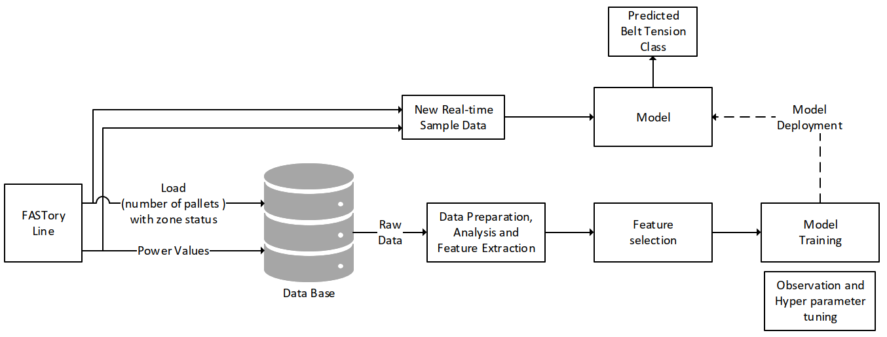

Figure : Main steps for development Data Driven Prognostic Model

# 5. Data Analysis~~, Discussion~~ and Results ~~and Discussion~~

~~Firstly,~~ In this section data collected for both static and dynamic cases will be analyzed thoroughly for each belt tension against all load combinations. The analysis of static case data helps to investigate lower threshold (minimum belt tension which induce motion in the belt under no load) and upper threshold value for belt tension. Furthermore, this analysis reveals useful insights on the relationship of belt tension, load and its position (active zone(s)) on conveyor and power consumption of belt’s motor driver. On the other hand, analysis of data collected under dynamic case is used to investigate, how belt tension effect pallet movement between conveyor zones and workstations. ~~After that ANN model traing prediction results on real time data will be presented.~~

## Analysis and Results for Belt Tensions 0% to 70%

During the experiments the belt tension is gradually increased from 0% to 95% according to Table 3 and load is varied on conveyor according to Table 2. For belt tension range 0% to 60%, it is concluded that these belt tension values are not useful for any operation as there is too much slip in the belt hence there is no motion in the belt. After a 10% increase in belt tension (70% belt tension), the motor driver head pully is in contact with belt and conveyor motor driver can provide enough traction force to overcome path resistances and puts conveyor belt into motion. For 70% belt tension only combinations 0 and 1 are used to collect power consumption data because as soon as there is a pallet on zone one, belt speed significantly reduces, and a jerky motion in belt as well as belt slippage at head pully was observed. This jerky motion is harmful for conveyor belt health and causes the belt wear which reduces belt life.

From the analysis of results obtained from static and dynamic cases it is concluded that 70% belt tension is the lower threshold value i.e. minimum belt tension which puts the belt into motion. Figure 7 illustrates, how power consumption is affected by variation of belt tension and presence of load on different zones of conveyor at a time. For better representation of data Author uses the box plot. The circles on boxes represents data mean ~~and numbers represents data median~~. Figure 7 contains the box plots for belt tension ranging from 0% to 70% and it can be seen that as soon as conveyor belt starts moving the power consumption of the driver motor increases due to friction between belt and head pully. On contrast, a decrease in motor driver power consumption is observed as soon as there is a pallet on the zone 1 of conveyor and reason is that the traction force generated with this belt tension is not enough to move the load on conveyor belt hence conveyor belt starts slipping from head pully.

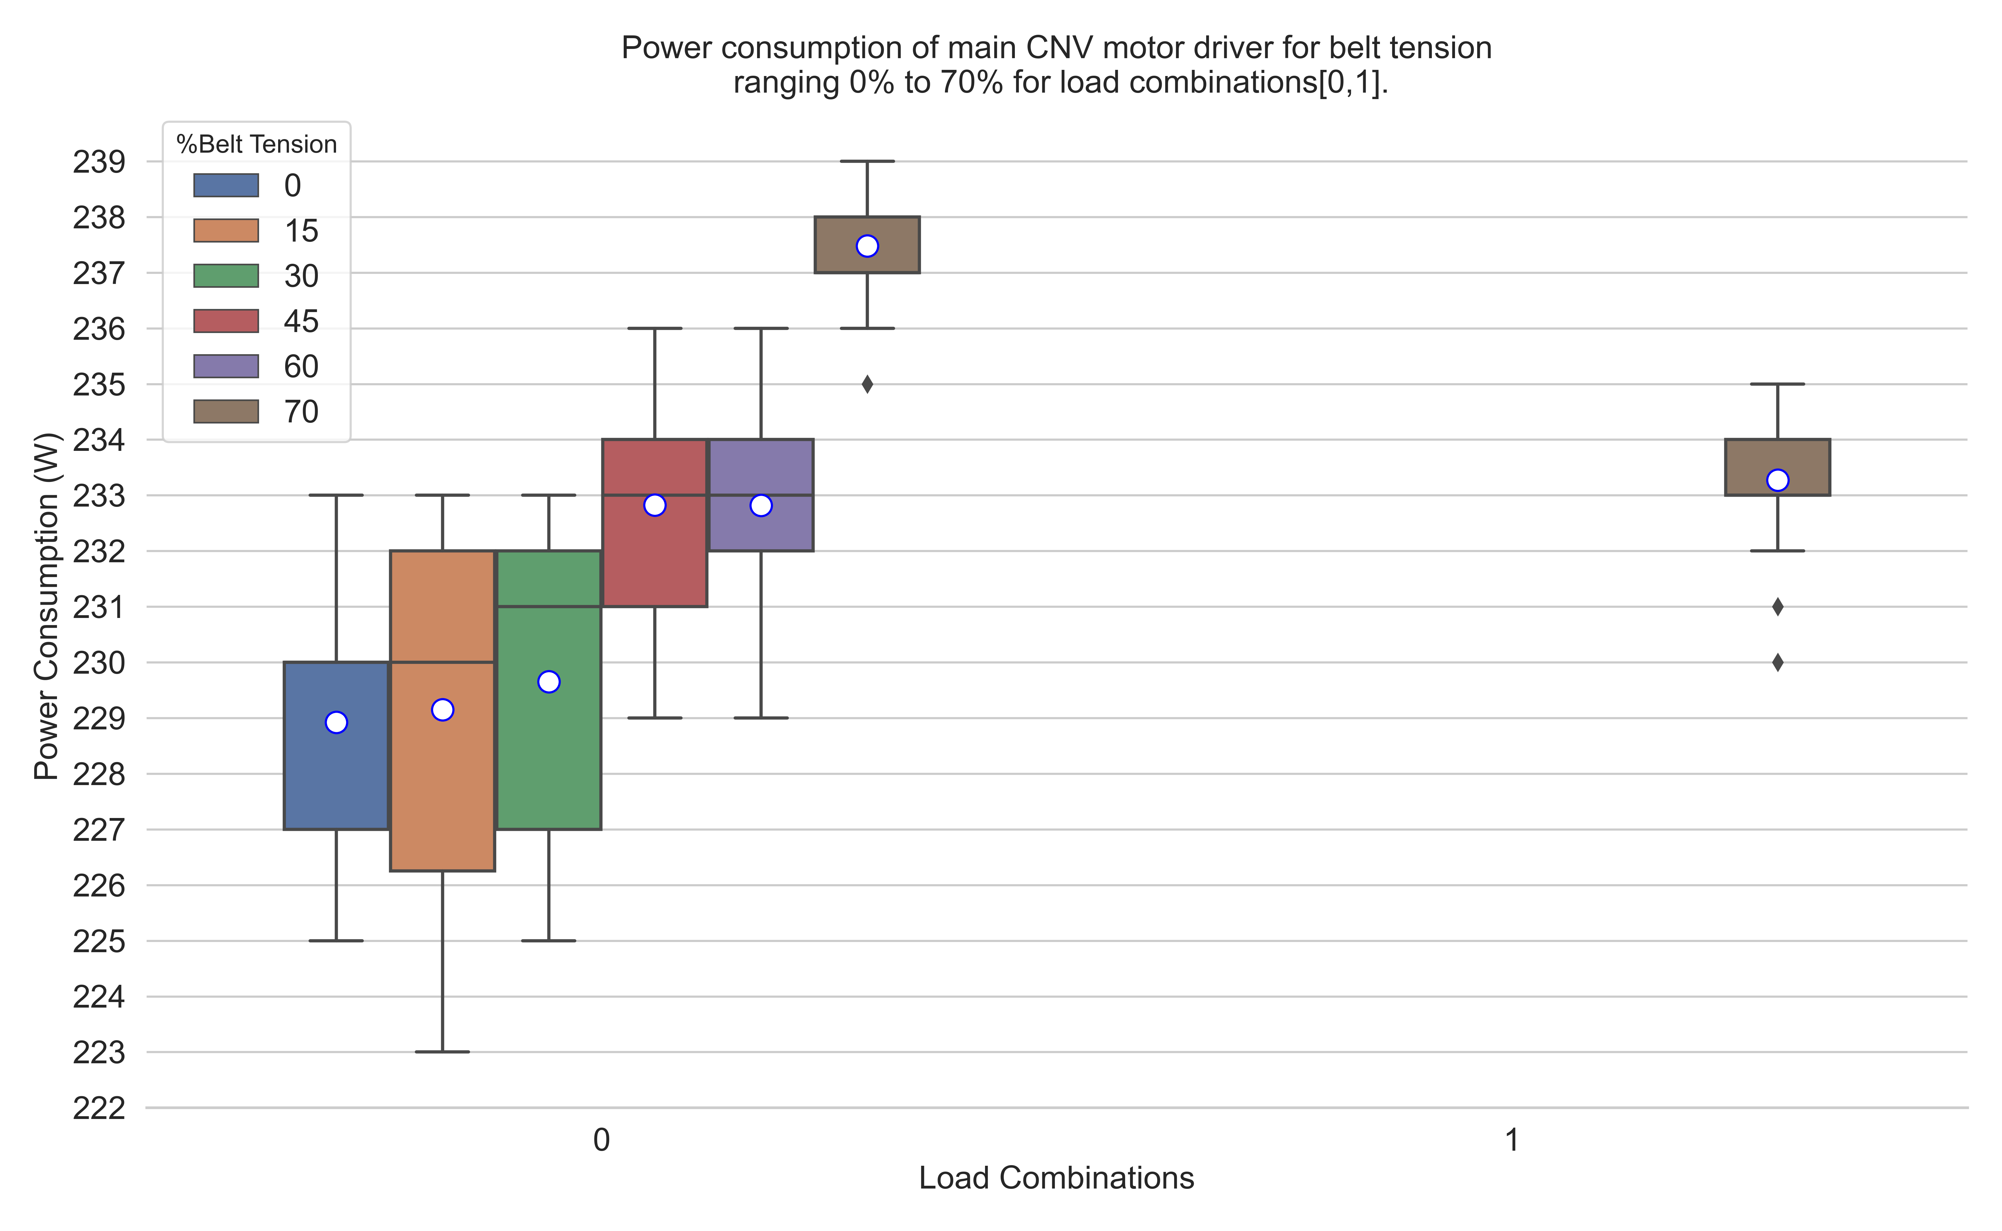

Figure : Effect of Belt Tension (0%-70%) and Load on Conveyor Motor Driver Power Consumption

Table 4 lists results for dynamic case data which shows how 70% belt tension affects the pallet movement on between conveyor zones. As 70% belt tension does not provide enough traction force to move pallets on conveyors which significantly increases material transportation time for example it took 120 sec to move a pallet from Z1 to Z5. During experiment belt mis tracking was observed when pallet moves between zone 3 and zone 5 and pallet never reach Z5 and stuck near Z5.

Table : Dynamic Case results for 70% Belt Tension

|  |  |  |  |  |  |  |
| --- | --- | --- | --- | --- | --- | --- |
| Belt Tension (%) | Active Zone | From | To | Distance(m) | Avg. Time(s) | Speed(m/s) |
| 70 | No | 1 | 5 | 1.61 | 120 | 0.013 |
| 70 | No | 1 | 2 | 0.61 | 80 | 0.008 |
| 70 | No | 1 | 3 | 0.835 | 86 | 0.01 |
| 70 | No | 3 | 5 | 0.773 | inf | 0 |

## Analysis ~~and Results~~ of Data collected for 75% Belt Tension

Figure 8 shows the boxplot of all load combinations for 75% belt tension. The circles on the boxplot represent data mean. For load combinations 0,1,2,4,8 only one zone on the conveyor is active, please see table 4 used load combinations for active zones. For combinations 0 and 8 the results are very similar and data median is 239(W). The reason is that for combination “0” we have a no-load condition wears for combination “8” there is one pallet at zone 5 which is similar to having no load due the fact that at zone 5 almost 75% of pallet reside on next workstation's conveyor. Power consumption for combinations “2 and 4” is similar and the data median for both combinations is 241. Here the power consumption is higher from other combinations due the fact that pallet is residing either on Zone 2 or Zone 3 due this there is increase in friction and motor driver supply more power to overcome that frictional force to maintain a smooth motion in belt. For these combinations no belt slip was observed.

For 3,5,6,9,10,12 load combinations, two zones on conveyor are active at a time. For combinations 3, 6 and 12 a relatively higher power consumption has been observed, also for combinations 3 and 12 data median is same (245(W)). Though for combinations 3 and 12 the active zones are different because result for these combinations depends on zone2 and zone3 respectively. For combinations 9 lowest power has been observed. Here the active zones are 1 and 5 they have very negligible effects on power consumptions, belt slip and speed. Out of these combinations the most prominent combination is 6, here both zone2 and zone3 are active at the same time. For this combination power consumption increased due to an increase in friction between belt and conveyance path significantly increased.

For load combinations 7,11,13,14,15 three zones on conveyor are active at a time except for combination 15 wear all zones are active. Out them combinations 7, 14 and 15 are the most prominent and for combinations 7 and 14 the active zones are zone1, zone2 and zone3 and for combination 15 all zones are active. For these combinations due to increase in friction between belt and conveyance path significantly increased due to which belt speed significantly reduces and a jerky motion was observed. For Combinations 11 and 13 active zones are zone 1,2,5 and zone 1,3,5 respectively. In contrast to combinations 7,14,15 for these combinations belt speed improves, slip decrees and jerky motion vanished and belt moves smoothly.

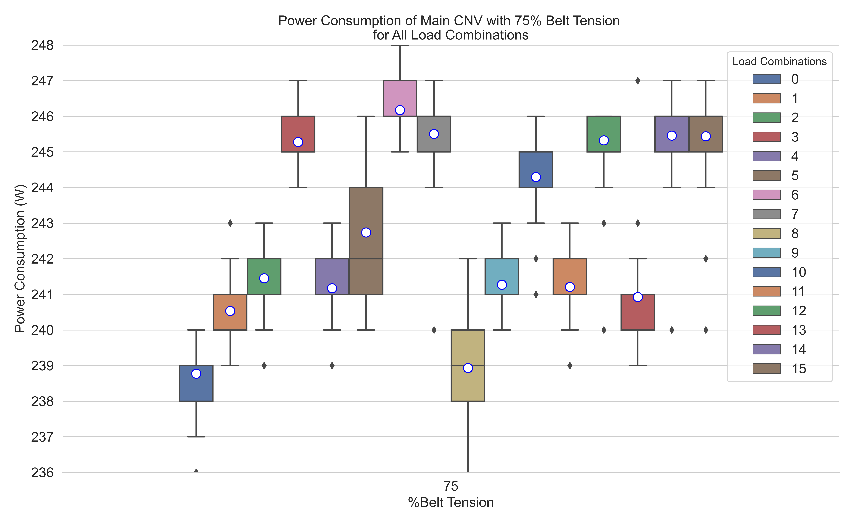

Figure : XXXXX

## Analysis of Data collected for 85% Belt Tension

Figure 12 shows the boxplot of load combinations 0,1,2,4,8 for 85% belt tension. For these combinations only one zone on the conveyor is active. For theses combinations an overall increase in belt power consumption was observed and this increase in power consumption is mainly due to increase in belt tension, in this case belt tension is 10% higher than previous case. Combinations 0, 1 and 8 have no significant effect on belt speed and slip but belt power consumption for each combination increased respectively.

Figure 13 shows the boxplot of load combinations 3,5,6,9,10,12 for 85% belt tension. For these Combinations two zones of conveyor are active at a time. Theses combinations have no negative effect on belt speed and slip as this belt tension. Only an overall increase in power consumption had been observed for each combination, the maximum power(246W) consumption recorded for combination 6 and a minimum(241W) for combination 12. For these combinations the presence of pallets on different zones only effects the power consumption of conveyor motor belt driver.

Figure 14 shows the boxplot for load combinations 7,11,13,14,15 for 85% belt tension. For these Combinations three zones of conveyor are active at a time except for combination 15. Combinations 7 and 14 are the most prominent and for this combination the active zones are zone1, zone2 and zone3 and zone2, zone3 and zone5 respectively. Combinations 11 and 13 both have same effect on parameters though the active zones are different in both combinations. the active zones for each combination are zone 1,2,5 and zone 1,3,5 respectively. These load combinations only affect conveyor belt power consumption and other parameters likes belt speed and slip remains same i.e., either no reduction in speed or increase in slip was observed.

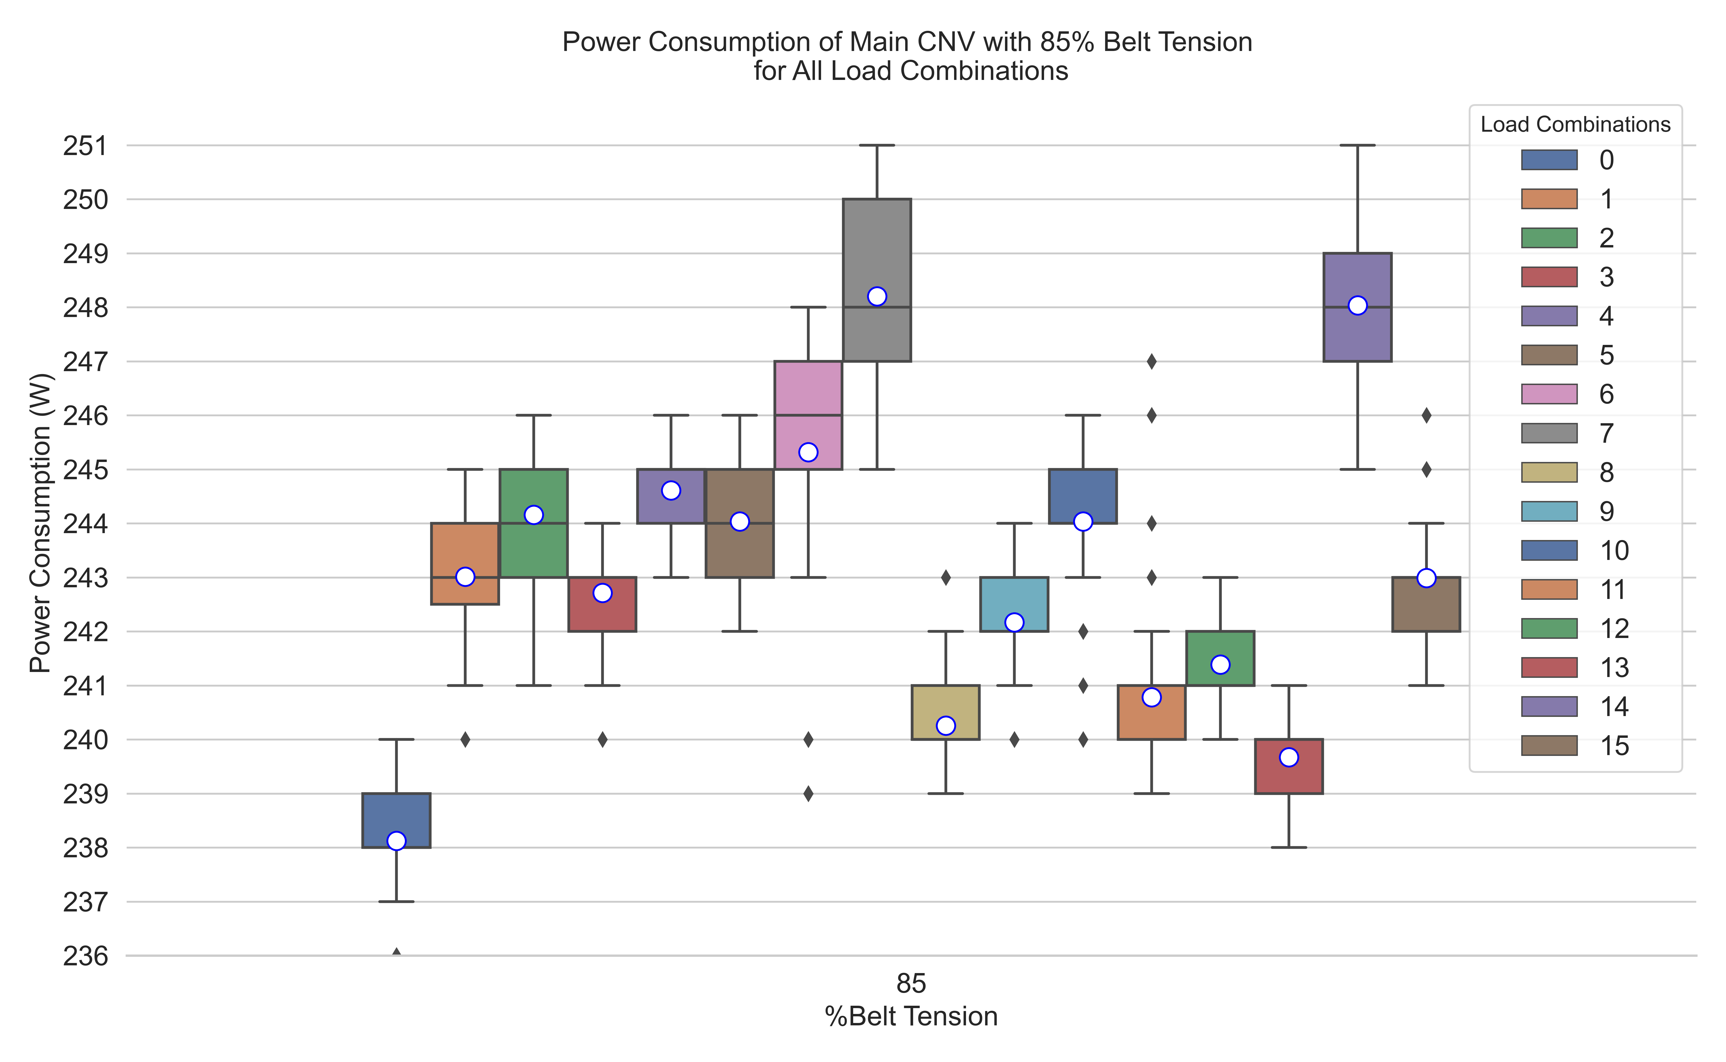

Figure : XXXXX

## Results for Belt Tensions 75% to 85%

For these belt tension a good and smoother belt motion is observed than previous belt tensions and no belt slippage at motor driver’s head pully was observed. For these belt tension this experiment is conducted for all load configurations i.e. experiment is repeated for each load combination (Table 4). Figure 8 illustrates, how conveyor motor driver power consumption is affected by these belt tension as well as presence of load on different zones of conveyor at a time. It can be seen from the box plot, for belt tension 85% there is an overall increase in the power consumption of conveyor motor driver for all combinations except 0 and 15 than 75% belt tension. Furthermore, power consumed by conveyor motor driver for both belt tension values is between 238W to 248W and it is also dependent on pallet presence on conveyor zone.

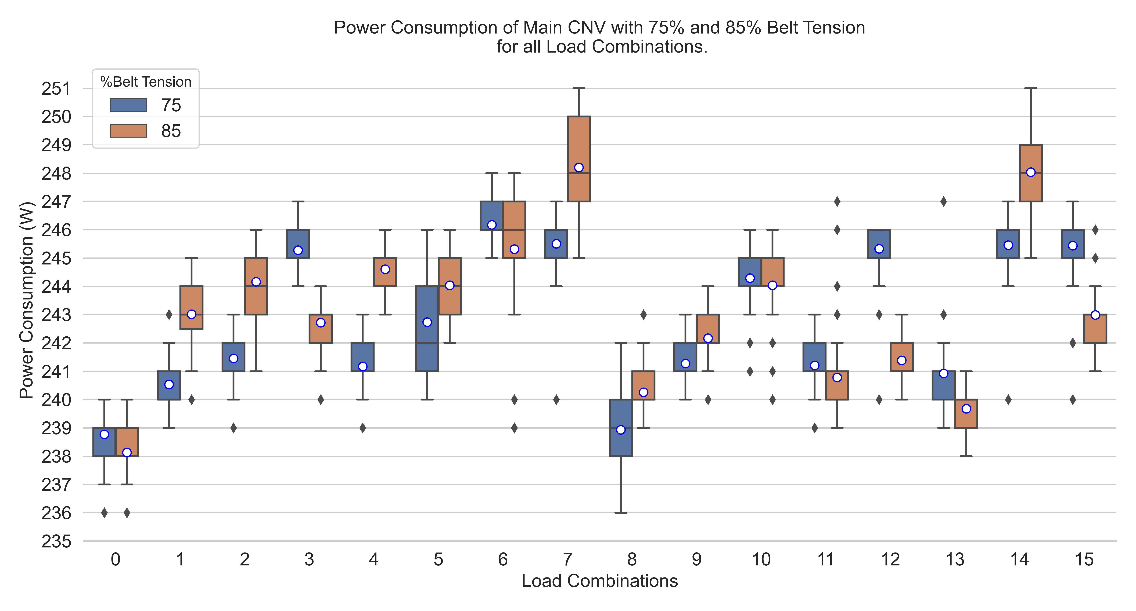

Figure : Effect of Belt Tension (75%-85%) and Load on Conveyor Motor Driver Power Consumption

Table 5 and Table 6 shows the dynamic case results for these belt tension with and without active zones.

Table : Dynamic Case results for 75%-85% Belt Tension with no Active Zones

|  |  |  |  |  |  |  |
| --- | --- | --- | --- | --- | --- | --- |
| Belt Tension (%) | Active Zone | From | To | Distance(m) | Avg. Time(s) | Speed(m/s) |
| 75 | No | 1 | 5 | 1.61 | 5.36 | 0.3 |
| 75 | No | 1 | 2 | 0.61 | 2.23 | 0.274 |
| 75 | No | 1 | 3 | 0.835 | 2.95 | 0.283 |
| 75 | No | 3 | 5 | 0.773 | 2.97 | 0.26 |
| 85 | No | 1 | 5 | 1.61 | 5 | 0.322 |
| 85 | No | 1 | 2 | 0.61 | 2.18 | 0.28 |
| 85 | No | 1 | 3 | 0.835 | 2.84 | 0.294 |
| 85 | No | 3 | 5 | 0.773 | 2.78 | 0.278 |

Table : Dynamic Case results for 75%-85% Belt Tension with Active Zones

|  |  |  |  |  |  |  |
| --- | --- | --- | --- | --- | --- | --- |
| Belt Tension (%) | Active Zone | From | To | Distance(m) | Avg. Time(s) | Speed(m/s) |
| 75 | Z5 | 1 | 3 | 0.835 | 2.91 | 0.287 |
| 75 | Z5, Z3 | 1 | 2 | 0.61 | 2.29 | 0.266 |
| 75 | Z1, Z2 | 3 | 5 | 0.773 | 4.24 | 0.182 |
| 75 | Z1 | 2 | 3 | 0.223 | 1.2 | 0.186 |
| 85 | Z5 | 1 | 3 | 0.835 | 2.85 | 0.293 |
| 85 | Z5, Z3 | 1 | 2 | 0.61 | 2.07 | 0.295 |
| 85 | Z1, Z2 | 3 | 5 | 0.773 | 2.89 | 0.267 |
| 85 | Z1 | 2 | 3 | 0.223 | 1.02 | 0.219 |

Refer to tables 5 and 6 it is observed that with 85% belt tension it took 5 sec for a pallet to move from zone 1 to zone 5 on the other hand it took 5.36 sec for a pallet to move from zone1 to zone 5 with 75% belt tension. One significant observation made for 75% belt tension, it took 4.24 sec for a pallet to move from zone 3 to zone 5 when two zones are active (Z1 and Z2) see Table 6. Beside that there is no significant difference between the dynamic case results of these belt tension and no abnormal behavior of transportation was observed for these belt tension.

## Analysis of Data collected for 95% Belt Tension

Figure 16 shows the boxplot of load combinations 0,1,2,4,8 for 95% belt tension. For these combinations only one zone on the conveyor is active. For combinations 0 and 8 the results are very similar because combination “0” we have a no-load condition wears for combination “8” we have one pallet at zone 5 which is similar to have no load due the fact that at zone 5 almost 75% of pallet reside on next workstation's conveyor. Combinations “2 and 4” are prominent and data mean for both combinations is 268(W) and 267(W) respectively. Here the power consumption is higher from other combinations due the fact that pallet is residing either on Zone 2 or Zone 3 due this there is increase in friction and conveyor belt’s motor driver supply more power to overcome that frictional force to maintain a smooth motion in belt.

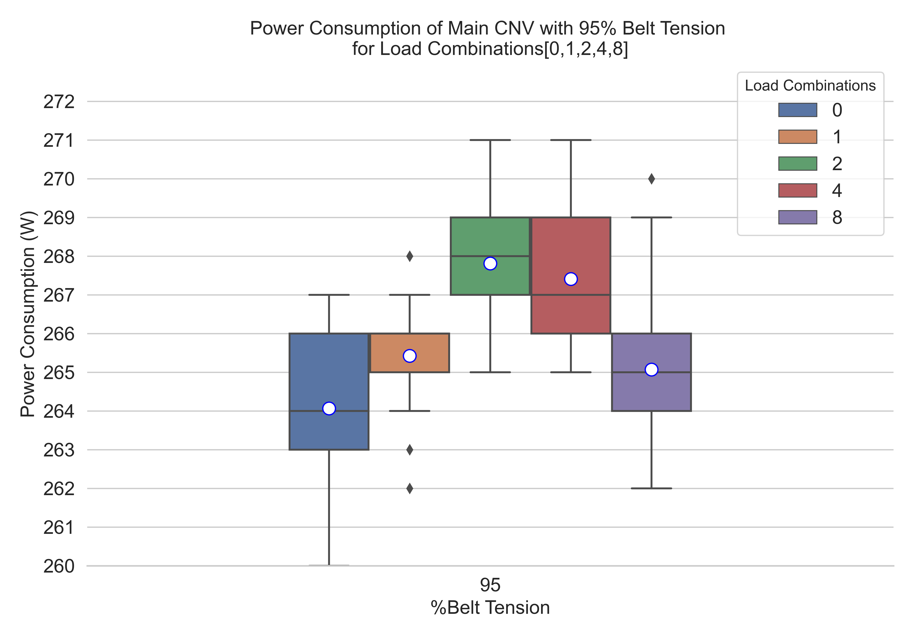

Figure : Power Consumption of Main CNV for Load Combinations 0,1,2,4,8

Figure 17 shows the boxplot for load combinations 3,5,6,9,10,12 with 95% belt tension. For these Combinations two zones of conveyor are active at a time. Combinations 3, 5 have similar effects on belt parameters and only belt driver’s power consumption is affected. For these combinations a significant increase in belt power consumption had been observed, it due to pallet load and an extra belt tension. For both combinations the data mean is 273(W). For these combinations the active zones are zone1, zone2 and zone1, zone3 respectively. For combination 9, lowest power consumption has been observed. Here the active zones are 1 and 5. Both combinations 10 and 12 have same data mean (272(W)) and similar effects like combinations 3 and 5. Out of these combinations the most prominent combination is 6, here both zone2 and zone3 are active at the same time and reveals some interesting effects. For these combinations there either no reduction in belt speed or no increase in belt slip.

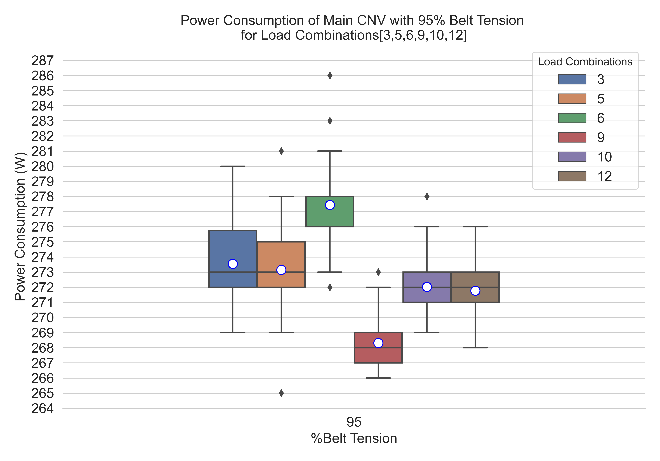

Figure : Power Consumption of Main CNV for Load Combinations 3,5,6,9,10,12

Figure 18 shows the boxplot for load combinations 7,11,13,14,15 with 95% belt tension. For these Combinations two zones of conveyor are active at a time except combination 15. Here Combination 7 and 15 are prominent and for this combination the active zones are zone1, zone2 and zone3 and all zones are active respectively. ~~As far as concerned with power consumption, it is significantly higher to combination 6(active zones are 2 and 3), here the data mean is 280(W) but other parameters like slip and speed are not affected by this combination.~~ Combinations 11 and 13 both only affects conveyor power consumption and remaining parameters remains unaffected, though the active zones are different in both combinations. the active zones for each combination are zone 1,2,5 and zone 1,3,5 respectively. Combination 14 has similar effect like combination 7 but has relatively less power consumption. Here the data mean is 277(W).

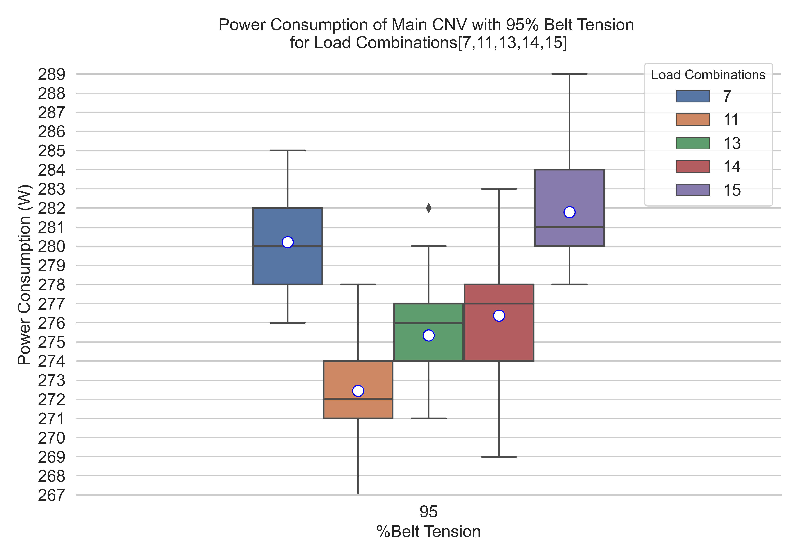

Figure : Power Consumption of Main CNV for Load Combinations 7,11,13,14,15

## Result for 95% Belt Tension

For this belt tension good and smoother belt motion is observed and there is no slip at head pully. Figure 9 illustrates, how conveyor motor driver power consumption is affected by these belt tension as well as presence of load on different zones of conveyor at a time. For this belt tension a significant increase in power consumption observed for all load combinations. This is the maximum belt tension which induce excessive stress on conveyor belt driver motor’s bearings and shafts so motor draws more current to produce enough torque to keep a smooth belt motion. This is an unhealthy operation condition which is harmful for both motor driver and conveyor belt. ~~The induced excessive stress can also cause the pulleys to break and wear down prematurely.~~ ~~Tracking problems can also arise leading to uneven belt wear.~~ For this belt tension this experiment is conducted for all load configurations.

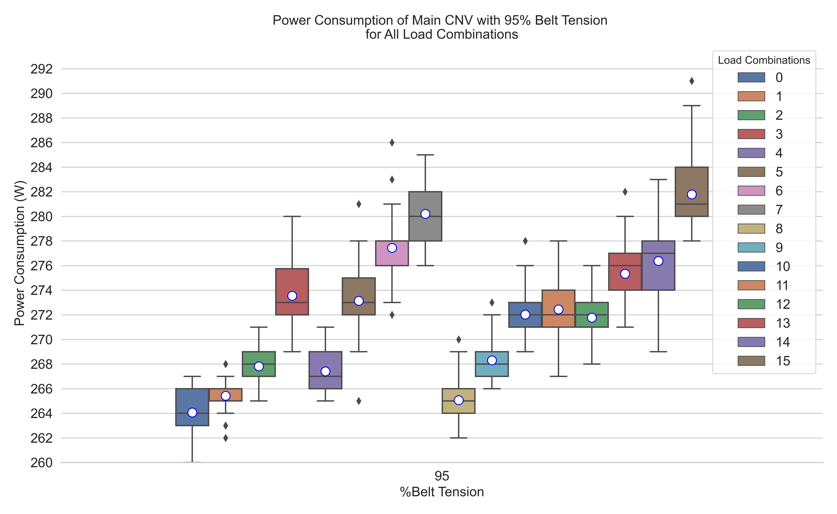

Figure : Effect of 95% Belt Tension and Load on Conveyor Motor Driver Power Consumption

Table : Dynamic Case results for 95% Belt Tension without Active Zones

|  |  |  |  |  |  |  |
| --- | --- | --- | --- | --- | --- | --- |
| Belt Tension (%) | Active Zone | From | To | Distance(m) | Avg. Time(s) | Speed(m/s) |
| 95 | No | 1 | 5 | 1.61 | 4.6 | 0.35 |
| 95 | No | 1 | 2 | 0.61 | 1.98 | 0.308 |
| 95 | No | 1 | 3 | 0.835 | 2.86 | 0.292 |
| 95 | No | 3 | 5 | 0.773 | 2.77 | 0.279 |

Table : Dynamic Case results for 95% Belt Tension with Active Zones

|  |  |  |  |  |  |  |
| --- | --- | --- | --- | --- | --- | --- |
| Belt Tension (%) | Active Zone | From | To | Distance(m) | Avg. Time(s) | Speed(m/s) |
| 95 | Z5 | 1 | 3 | 0.835 | 2.85 | 0.293 |
| 95 | Z5, Z3 | 1 | 2 | 0.61 | 1.99 | 0.307 |
| 95 | Z1, Z2 | 3 | 5 | 0.773 | 2.8 | 0.276 |
| 95 | Z1 | 2 | 3 | 0.223 | 1.02 | 0.219 |

## Comparison Boxplots for Belt Tensions

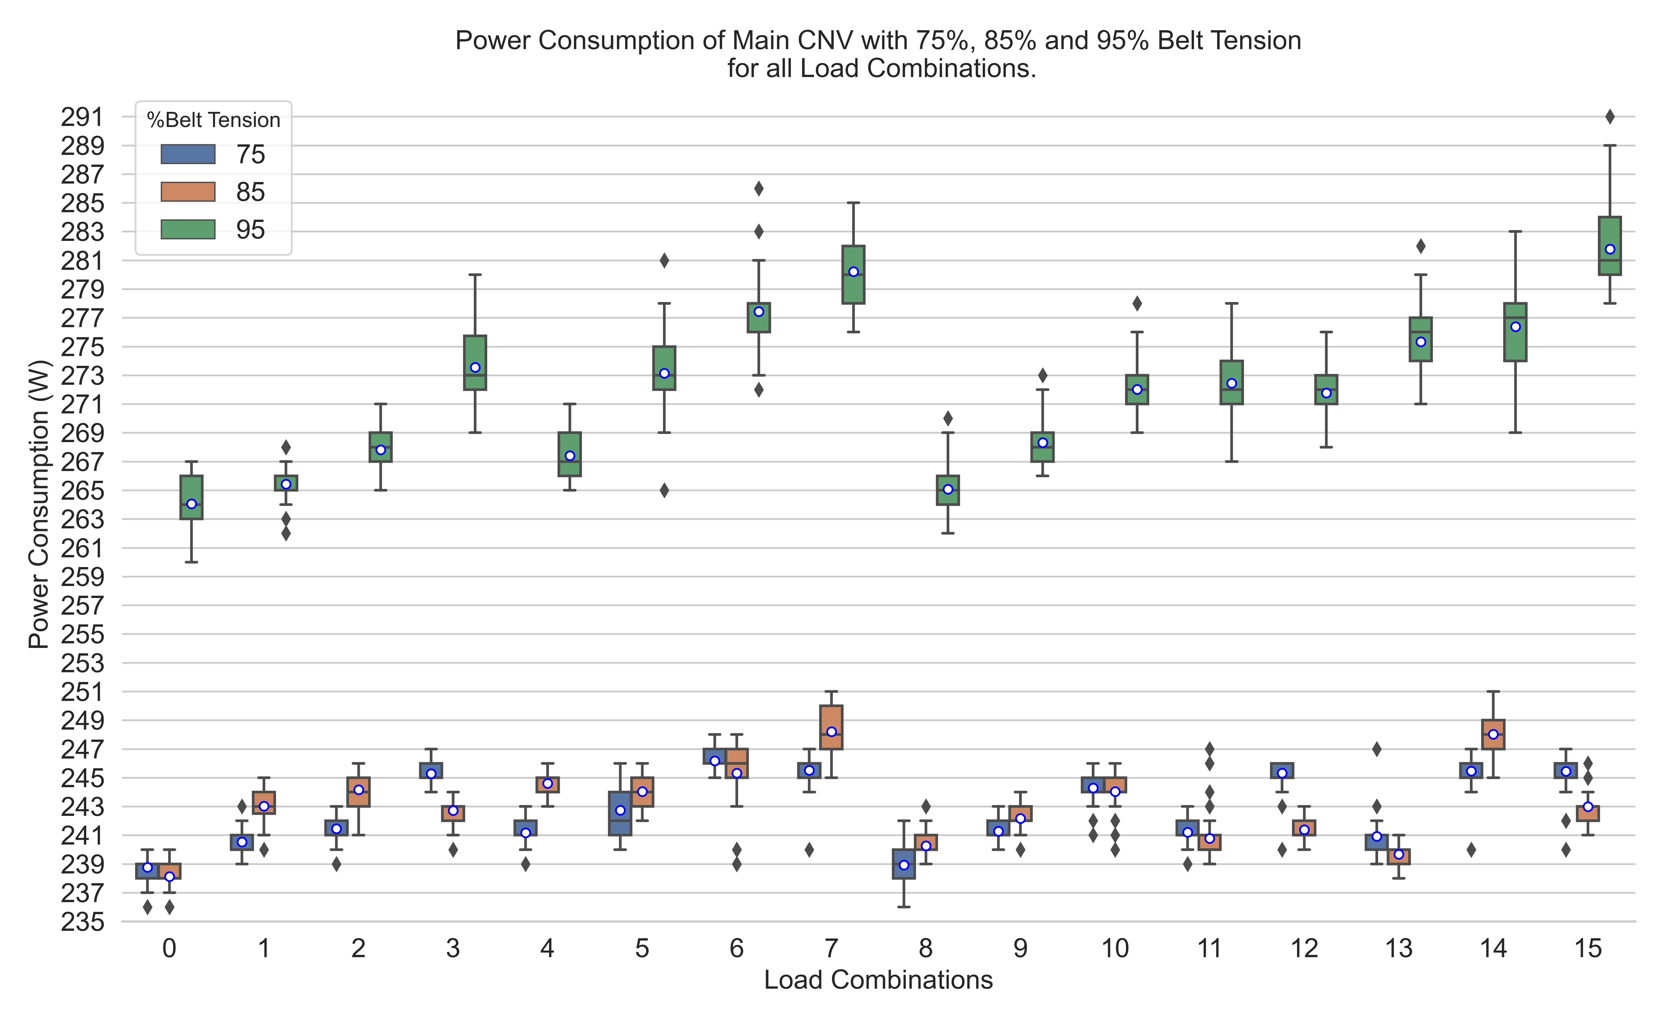

Based on the above results the lower and upper threshold belt tension values are selected. These values are represented below, any belt tension value which is between these threshold values is consider as useful belt tension, see Figure 10.

$$Not useful belt tension≤70\% (lower threshold) \\ 95\% (upper threshold)≤Not useful belt tension (over tense) \\ 75\%<useful belt tension \left(75\% upto 90\%\right)<95$$

Figure 10 shows boxplot for each belt tension used for collecting data in this research work. Each box plot in Figure 10 represents power consumed by conveyor belt motor driver for all load combinations corresponding belt tension. Boxplots representing useful belt tensions are highlighted as green color. This figure is useful for quick analysis of data as data visualization is good this grouped boxplot. It looks like belt tension and motor driver power consumption are related by an exponential function but it’s not true due to load on the conveyor and its corresponding zone position.

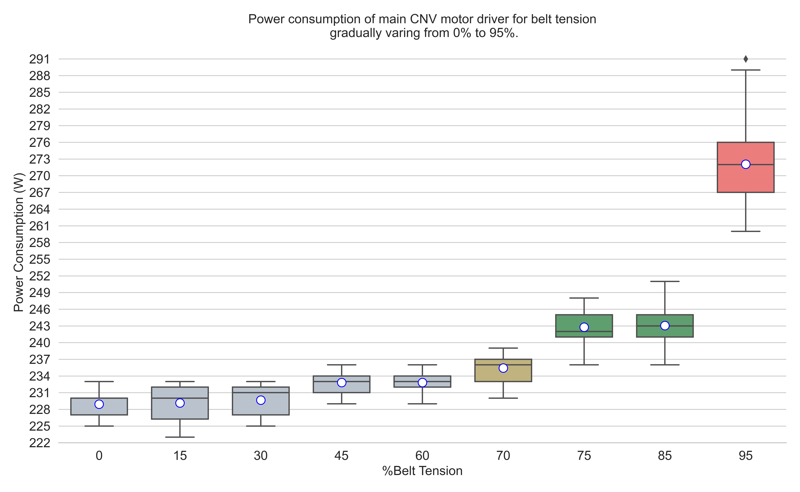

Figure : Cumulative Plot for all Load Combinations with Belt Tension Range 0%-95%

## Model Training and Prediction Results

The belt tension predictor model which is an artificial neural network is trained using the static case data with the aim to predict an early stage behavioral deterioration of conveyor belts. This ANN is used for multiclass classification to predict a belt tension class Cm, where m is 1,2 or 3 which represents low, optimal and over tense belt tension class, see Table 9.

Table : Belt Tension Classes corelating to %Belt Tension Values

|  |  |  |
| --- | --- | --- |
| Class | Belt tension Values in % | Description |
| 1 | 0% to 70% | Not use full |
| 2 | 75% to 85% | Use full (nominal) |
| 3 | Belt Tension>90% | Not useful (over tense) |

Static case data includes more than 5000 data samples collected for FASTory line at a sampling rate of 1 second, out of these samples 80% are used for ANN training and 10% samples are used for validation, remaining 10% data samples are used for testing the model. The computed loss/error i.e. the average percentage of the number of unsuccessful predicted classes is 3.2%. This misclassification error observed for only those data samples that corresponds to no load situation i.e. load combination 0 for belt tensions 70%, 75% and 85% due data overlapping and low separation boundary. Another reason for this error is that the conveyor power consumption does not change instantly once conveyor workload is modified, but after a short time delay. This delay is responsible for the few outliers. Such occurrences may influence the value of the calculated error. Figure 11 illustrates data overlapping by plotting box plots for load combinations 0 and 1 with belt tension range 0% to 85%.

After testing, model is used for prediction on real-time data coming from FASTory line and prediction results are according to expectations. Similar to test data same misclassification observed for real-time and the reason of this misclassification is already explained, see Table 10 for misprediction results. Table 11 lists real-time prediction results for some data samples collected from 1500 real-time predicted data samples. During real-time prediction both belt tensions and load are varied by line operator according to Table 3 and Table 2 respectively.

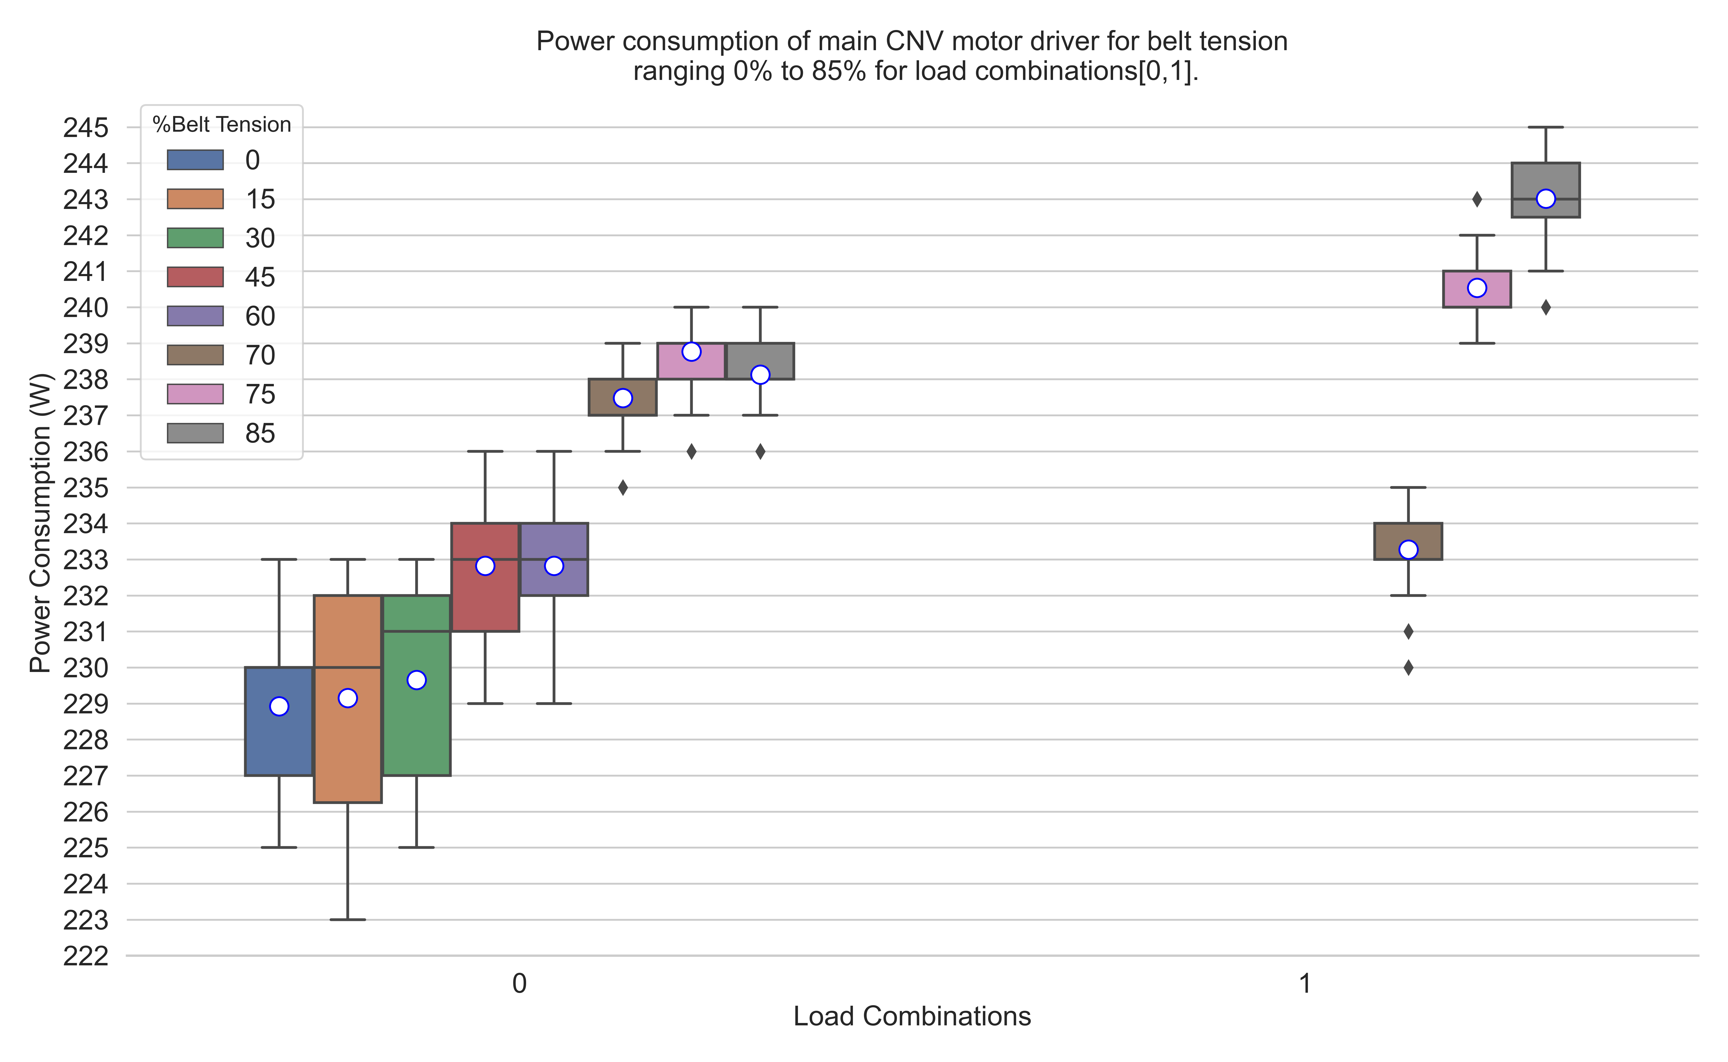

Figure : Misprediction Cause

The belt tension predictor model aimed to predict an early stage behavioral deterioration of conveyor belts. ANN model gets every second a new real-time data sample from FASTory line which contains power consumption values and load information. ANN model processes this new incoming data and predict a belt tension class. Through backend logic the newly predicted belt tension class is compared to last 10 predicted classes. Getting consecutive mismatch between new and last 10 predicted belt tension classes implies a gradual deterioration of belt tension from nominal belt tension range. Hence the power values observed no longer correlate as expected to the semantics defined statically, meaning that for each belt tension (Table 3) the belt driver engine consumes power within certain range, see Figures 7,8,9,10, therefore necessary maintenance steps must be taken to correctly adjust belt tension to avoid catastrophic hazards.

Table : Mis predicted Classes

|  |  |  |  |  |  |
| --- | --- | --- | --- | --- | --- |
| **True Class** | **Power (W)** | **Load_Combination** | **Active_Zone** | **Pred_Class** | **Time** |
| 2 | 232.6 | 0 | 0000 | 1 | 04/22/2021, 13:28:23 |
| 2 | 232.6 | 0 | 0000 | 1 | 04/22/2021, 13:28:24 |
| 2 | 232.554 | 0 | 0000 | 1 | 04/22/2021, 13:28:25 |
| 2 | 232.554 | 0 | 0000 | 1 | 04/22/2021, 13:28:26 |
| 2 | 232.52 | 0 | 0000 | 1 | 04/22/2021, 13:28:27 |
| 2 | 234.269 | 1 | 1000 | 1 | 04/22/2021, 13:29:27 |
| 2 | 234.269 | 1 | 1000 | 1 | 04/22/2021, 13:29:28 |
| 2 | 234.389 | 1 | 1000 | 1 | 04/22/2021, 13:29:29 |
| 2 | 234.389 | 1 | 1000 | 1 | 04/22/2021, 13:29:30 |
| 2 | 234.486 | 1 | 1000 | 1 | 04/22/2021, 13:29:31 |

Table : Results from 1500 real-time predicted data Samples

|  |  |  |  |  |  |
| --- | --- | --- | --- | --- | --- |
| **True Class** | **Power (W)** | **Load_Combination** | **Active_Zone** | **Pred_Class** | **Time** |
| 1 | 229.855 | 0 | 0000 | 1 | 04/22/2021, 13:56:55 |
| 1 | 229.931 | 0 | 0000 | 1 | 04/22/2021, 13:56:56 |
| 1 | 230.124 | 0 | 0000 | 1 | 04/22/2021, 13:59:12 |
| 1 | 230.124 | 0 | 0000 | 1 | 04/22/2021, 13:59:13 |
| 2 | 235.945 | 2 | 0100 | 2 | 04/22/2021, 13:30:29 |
| 2 | 236.23 | 2 | 0100 | 2 | 04/22/2021, 13:30:33 |
| 2 | 237.16 | 4 | 0010 | 2 | 04/22/2021, 13:32:49 |
| 2 | 237.16 | 4 | 0010 | 2 | 04/22/2021, 13:32:50 |
| 2 | 237.481 | 8 | 0001 | 2 | 04/22/2021, 13:33:50 |
| 2 | 237.203 | 8 | 0001 | 2 | 04/22/2021, 13:33:51 |
| 2 | 233.321 | 9 | 1001 | 2 | 04/22/2021, 13:37:42 |
| 2 | 233.413 | 9 | 1001 | 2 | 04/22/2021, 13:37:43 |
| 2 | 234.881 | 10 | 0101 | 2 | 04/22/2021, 13:42:40 |
| 2 | 235.085 | 10 | 0101 | 2 | 04/22/2021, 13:42:41 |
| 2 | 236.684 | 12 | 0011 | 2 | 04/22/2021, 13:43:24 |
| 2 | 236.684 | 12 | 0011 | 2 | 04/22/2021, 13:43:25 |
| 2 | 237.733 | 13 | 1011 | 2 | 04/22/2021, 13:44:52 |
| 2 | 238.072 | 13 | 1011 | 2 | 04/22/2021, 13:44:55 |
| 2 | 244.243 | 14 | 0111 | 2 | 04/22/2021, 13:46:44 |
| 2 | 244.497 | 14 | 0111 | 2 | 04/22/2021, 13:46:45 |
| 2 | 244.134 | 14 | 0111 | 2 | 04/22/2021, 13:47:47 |
| 2 | 244.112 | 14 | 0111 | 2 | 04/22/2021, 13:47:48 |
| 2 | 243.037 | 11 | 1101 | 2 | 04/22/2021, 13:49:17 |
| 2 | 242.81 | 11 | 1101 | 2 | 04/22/2021, 13:49:18 |
| 2 | 243.188 | 13 | 1011 | 2 | 04/22/2021, 13:51:01 |
| 2 | 243.188 | 13 | 1011 | 2 | 04/22/2021, 13:51:02 |
| 2 | 247.281 | 15 | 1111 | 2 | 04/22/2021, 13:53:28 |
| 2 | 247.379 | 15 | 1111 | 2 | 04/22/2021, 13:53:29 |
| 3 | 252.693 | 0 | 0000 | 3 | 04/22/2021, 13:59:41 |
| 3 | 252.693 | 0 | 0000 | 3 | 04/22/2021, 13:59:42 |
| 3 | 255.959 | 1 | 1000 | 3 | 04/22/2021, 14:02:40 |
| 3 | 255.959 | 1 | 1000 | 3 | 04/22/2021, 14:02:41 |
| 3 | 256.048 | 2 | 0100 | 3 | 04/22/2021, 14:02:42 |
| 3 | 256.048 | 2 | 0100 | 3 | 04/22/2021, 14:02:43 |
| 3 | 257.72 | 2 | 0100 | 3 | 04/22/2021, 14:02:57 |
| 3 | 258.19 | 4 | 0010 | 3 | 04/22/2021, 14:04:54 |
| 3 | 258.19 | 4 | 0010 | 3 | 04/22/2021, 14:04:55 |
| 3 | 256.834 | 8 | 0001 | 3 | 04/22/2021, 14:06:28 |
| 3 | 256.501 | 8 | 0001 | 3 | 04/22/2021, 14:06:29 |
| 3 | 279.917 | 9 | 1001 | 3 | 04/22/2021, 14:08:02 |
| 3 | 280.485 | 9 | 1001 | 3 | 04/22/2021, 14:08:03 |
| 3 | 279.053 | 10 | 0101 | 3 | 04/22/2021, 14:08:46 |
| 3 | 279.053 | 10 | 0101 | 3 | 04/22/2021, 14:08:47 |
| 3 | 280.309 | 12 | 0011 | 3 | 04/22/2021, 14:10:21 |
| 3 | 280.309 | 12 | 0011 | 3 | 04/22/2021, 14:10:22 |
| 3 | 287.266 | 13 | 1011 | 3 | 04/22/2021, 14:11:54 |
| 3 | 287.151 | 13 | 1011 | 3 | 04/22/2021, 14:11:55 |
| 3 | 282.805 | 14 | 0111 | 3 | 04/22/2021, 14:13:02 |
| 3 | 282.805 | 14 | 0111 | 3 | 04/22/2021, 14:13:03 |
| 3 | 286.667 | 15 | 1111 | 3 | 04/22/2021, 14:14:59 |
| 3 | 286.667 | 15 | 1111 | 3 | 04/22/2021, 14:15:00 |
| 3 | 288.67 | 11 | 1101 | 3 | 04/22/2021, 14:15:01 |
| 3 | 288.67 | 11 | 1101 | 3 | 04/22/2021, 14:15:02 |
| 3 | 298.24 | 7 | 1110 | 3 | 04/22/2021, 14:18:44 |
| 3 | 298.24 | 7 | 1110 | 3 | 04/22/2021, 14:18:45 |

# 6. Conclusion and Future Work

In this paper power signature from conveyor belt driver is used to describe expected system behavior. In summary, power consumption values are monitored and classified for a real cell phone assembling line. During training phase, the power signature of the system components is associated with semantics concerning the conveyor belt tension and workload of the conveyor belts. At validation phase, real time data coming from the line is input to the predictor model and the output obtained (belt tension class). Consecutive mismatch between new and last 10 predicted belt tension classes implies a gradual deterioration of belt tension from nominal belt tension range which pinpoints to an incipient gradual deterioration of expected behavior of equipment. In the presented scenario, such deterioration would translate to a gradual loss of belt tension of conveyor and maintenance steps must be taken for equipment to avoid catastrophic hazards.

Future research will focus on bringing more parameters for analysis, in addition to power consumption and load, to increase the number of dimensions of the available datasets. Vibration and temperature sensors are available in the testbed and can be used wherever applicable (e.g. for the robots).

Unused pictures:

Following pictures can be used for detail analysis and comparison but may be redundant as these pictures contains analysis of power consumption and load combinations for specific belt tension.

